ANNUAL REPORT 2022-23
St John the Evangelist
Hurst Green, May 2023

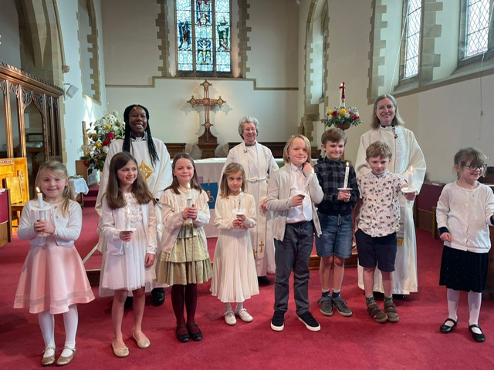
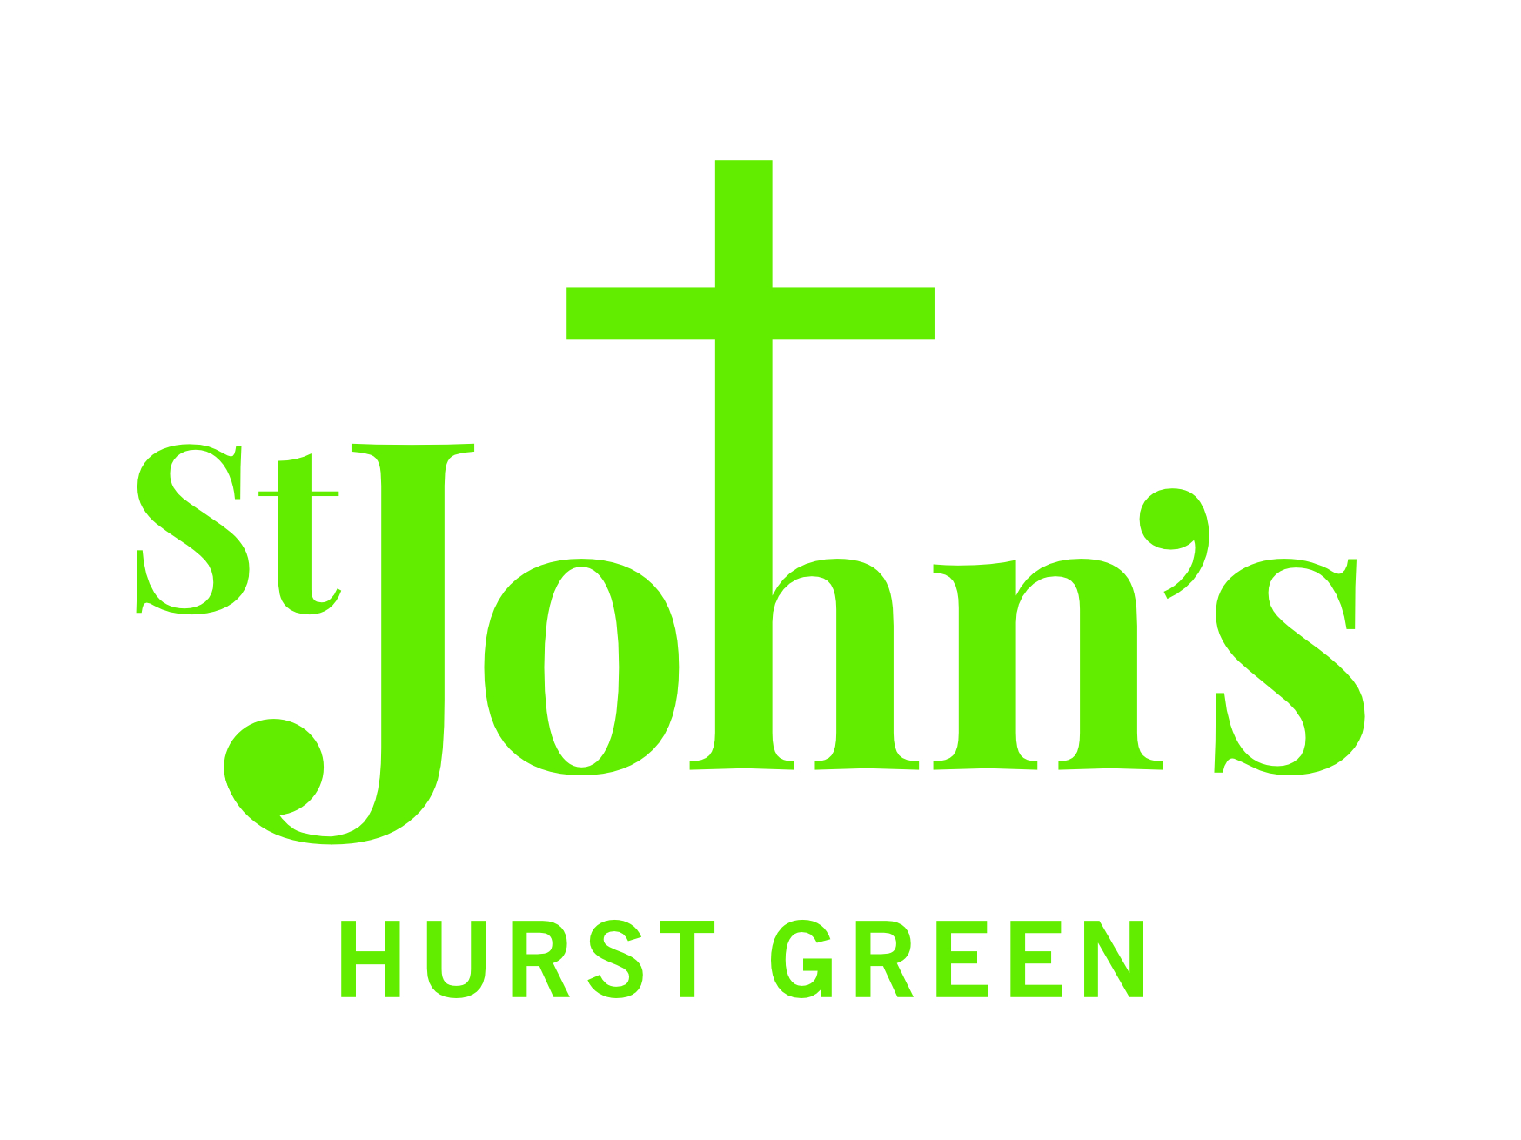
Rector’s Report
"Now faith is the assurance of things hoped for, the conviction of things not seen." Hebrews 11 v1

At the end of this equivalent report last year I wrote 'let's hope and pray 2022 will be a calmer year than last, that the sun will shine and the future become clearer and more certain'.

Well, I do think that has happened! I know the recent news of my departure may feel like it has rocked the boat. But on the other hand this year at St John's has seen a real clarity of vision and hope for the future emerge. And as the quote from Hebrews above states, as Christians we learn to live by faith and by hope in a way that is confident and assured and convicted. Even though in some ways St John's is about to face the biggest change of this last decade, at the same time I think the church and its people do so confidently, in sure hope and in strong faith.

Change is a part of life. But we do tend to try to resist it. I was struck by this quote recently too:

"I used to think that things were real, and change was something that happened to them over time. Now I think that change is real, and things are events that happen over time. Change is the constant and things come and go, appear and disappear." Brian McLaren, Do I Stay Christian?

Our world and our country might appear to face diminishing hope and great uncertainty, but somehow that is fertile ground for our faith in God to grow stronger. Of all my time at St John's and in the Oxted Team I would say the last year or two I have felt the greatest and strongest sense of God and his Spirit at work, not just in the church but in amongst the people we encounter through our mission and ministry. It is also the time I have felt most hopeful for the future and most excited about what God is doing and has in store for us. Every week it seems we encounter new opportunities to share God's love and the message of Jesus in our actions but also, gently, in our words, all empowered and equipped by the Holy Spirit. When the foundations around us seem uncertain, our foundation in God is strong. When we really need him, he is there, in Jesus.

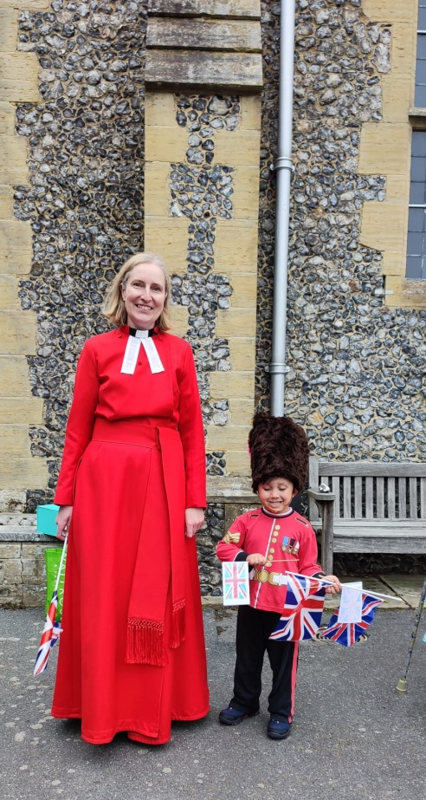
Although there is never a good time to move on, perhaps now is the best time. The family and I are very sad to leave so many wonderful friends. But I have no doubt we will still feel part of the communion of all believers, hopefully see some of you now and then, and will keep in touch with updates as the vision to be a 'church without walls' becomes a reality. And not only do I have great hope and faith in God for the future both here and in my own pastures new, but also I have deep faith and hope in his people. There are so many committed and passionate lay people and clergy here at St John's now and across the team, both of many years and some of just a few months, that I know all will be well. Although I am sad to leave I am also rejoicing. Please don't read that the wrong way, but I want to write it nonetheless.... I want you to know how joyful I am to have known and loved you, to have been known and loved by you, and to leave so convinced and assured of a hopeful future for God's Kingdom in this place.

As always, thank you to each and every one of you for your love and faithfulness towards God and his people, shown in your many good deeds and great kindness. Thank you for the last 10 years and in particular the kindness and love you've shown myself and my family, especially during the toughest of times. And God Bless us all as we move forwards together in spirit, yet now apart.

Revd Canon Anna Eltringham, Rector Oxted Team

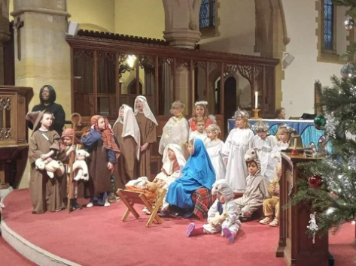
Churchwardens’ Report
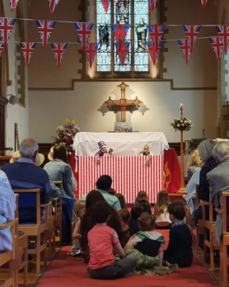
We’re beginning to wonder if there is such a thing as a “normal” year in the life of a churchwarden! Over the last few years, we’ve dealt with Anna’s absences due to illness, the appointment of Anna as Rector, a pandemic, the Queen’s Platinum Jubilee, the death of Queen Elizabeth and more recently the celebration of the coronation of King Charles III. And, in the last year, we’ve had to remember how to do some of the special services such as Remembrance Sunday, and Christmas in the way we used to do them pre-pandemic!

Of course, the news now uppermost in our minds is the imminent departure of Anna, as she prepares to move away to start her new ministry. It’s a bitter-sweet moment as we will miss her wisdom, vision, spirituality, support and friendship; but we’re also very proud of what she has achieved in the nine years she has spent with us. She leaves us at a time when we are planning some very big changes and with God’s help, and a strong team of people we will be able to fulfil our vision to be a church without walls at the heart of the Hurst Green community. We wish Anna, Nigel, Amelie and Isobel every happiness in their new home.

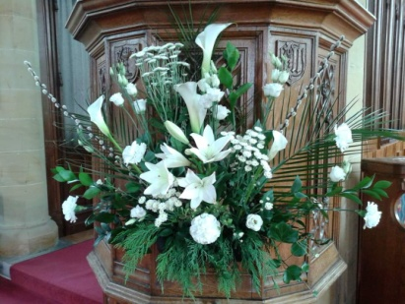
The next few months are going to be a strange time for us and that can make us anxious, but we will work together and embrace this time to build on our achievements and grow and develop as a church. We will be very well supported by Mary, Lotwina, Wendy and the wider Oxted clergy team.

Finally, thank you to those people who make St John’s such a special place - our clergy and lay ministers, the PCC, those who help with flowers, cleaning, the grounds, music, refreshments, youth workers, Sunday school teachers, the café church team, sidespersons, intercessors, servers, crucifers, sacristans and to everyone who helps in whatever way.

Cathy Booth and Henk van den Berg, Churchwardens

Fabric

Having had a mains water leak at the end of 2021 our insurers paid for the repair of the leak in 2022 and for the cost of the leaked water. However, we're still contesting the water authority’s (SES Business) large charge for ‘water disposal’.

A user-friendly quality camera system has been installed in the church. This has proved very useful in allowing those people who have been hesitant to come to the church during the latter stage of the Covid pandemic to see and hear the main Sunday services from home. We were grateful for assistance from Gareth Iles, a local sound engineer, to improve the clarity of our sound system by fine-tuning the control settings for our various new microphones.

A major cost item was the replacement of our high-level smoke-alarm detectors. This was a protracted process as it needed the use of scaffolding towers, and replacement of some of the wiring. There is still a problem to resolve with a failed unit in the system’s control panel.

Various maintenance requirements and repairs were carried out around the church, including some which were recommended by the 2021 Quinquennial inspection:

- Repointing outside masonry around the church, including re-setting loose flints
- Repointing the flat stonework by the main entrance
- Sanding and re-staining the Main and West doors
- Repair of the broken hinges on the tower-roof door
- Re-setting of drainage grid covers at the bottom end of the drive
- Replacement of broken roof tiles
- Installing safety-strap rings to allow safe ladder attachment when accessing the York Rooms and St John’s Room flat-roofs
- Changing the clergy vestry wardrobe hanging system and treating local woodworm issue
- Repairing a toilet flushing unit
- Recoating York Rooms roof capping stones with water-repellent fluid
- Cleaning exterior surfaces of skylights on York Rooms and St John’s Room roofs
- Applying Forensic ‘Smart Water’ to roof lead and audio-visual equipment, to discourage theft (this allows identification as having come from St John’s)
- Improving woodwork so securing bolt operates in vestry sound cupboard
- Main church entrance lobby disabled-toilet door sanded/planed to ease closing
- York Rooms lobby toilet and Server’s vestry door locks repaired
- Replacement of mechanism on one of the sliding door panels in the York Rooms

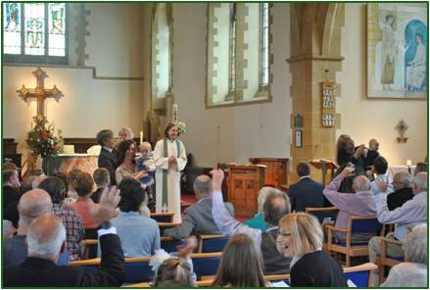
There were quite a few no-longer-wanted items in the tower room and the various vestries. These have been disposed of (including a number of surplus chairs which were sold to a keen beneficiary) and remaining items in the vestries re-organised to improve their layout and efficient use.

In addition were the routine servicing of the boilers and heating system and fire alarm system (alarms, emergency lights, fire extinguishers).

Chris Johns
Finances
Headlines for 2022
For the full accounts please see the Appendix at the back of this report. But read on here for a summary of 2022 and what we can expect for 2023…

2022 represented a return to near normality after 2 years living with the effects of the Covid-19 pandemic. Giving rose to £105K (2021: £96K), comprising Planned Giving up £6K to £74K (2021: £68K) and Other Giving up £4K to £13K (2021: £9K), and Gift Aid of £19K. This total is a significant improvement over the Covid period but has not resumed the levels seen before the pandemic (the equivalent figure for 2019 was £119K).

Activities for Generating Funds saw a very useful further increase to £32K (2021: £23K), with a strong performance in St. Agatha’s hires up nearly £7K to £18K. Statutory Fees Retained for weddings and funerals also saw an increase to £4K (2021: £3K), with no Covid restrictions in 2022.

Grants saw a drop to £13K (2021: £17K), primarily with the ending of Covid employee Furlough and Tandridge District Council business restriction grants for St. Agatha’s.

Overall, there was an increase in Income to £155K (2021: £141K).

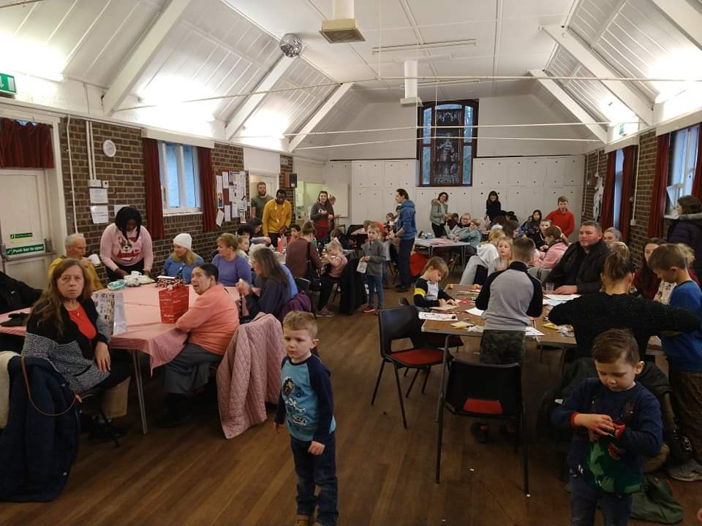
The PCC agreed to a 2% increase in our pledge to the Parish Support Fund to £64K (2021: £63K). With St. John’s undertaking more outreach and social initiatives of its own, principally Community Fridge and Warm Hub at St. Agatha’s, Mission Giving from our own funds remained at only £0.3K (2021: £0.3K). However, this doesn’t include at least £2.2K (2021: £2.3K) passed directly to good causes from appeals – see Note 1d) in the Accounts for a list of beneficiaries.

Non-Clergy Salaries increased to £26K (2021: £19K) with the number on the payroll rising to 7 people, though two of the activities (Communications and Youth worker) are grant funded.

Other PCC running expenses were up to £52K (2021: £32K), with £15K of the £20K increase being one-offs for Equipment covering the new filming system, photocopier and upgrades to the sound system. Routine Building and Grounds Maintenance also increased £4K to £11K, but there were no Major Repairs & Improvements.

Overall, expenses rose £149K (2021: £132K), and with a book loss on the value of investments of £(1)K (2021: gain £1K), the PCC showed a surplus of £4.5K for the year (2021: surplus £11K). Net Funds therefore grew to £123K, up from £119K at end of 2021.

Looking forward to 2023
We assumed for the 2023 budget that giving, hire and Hurst Green News income will remain broadly in line with 2022, but, taking the prudent view, no grant income was included.

However, since the budget was calculated, the Crossing the Threshold project has been formally announced. This should include a consistent and higher income from the church rooms from as early as autumn 2023 but will also involve considerable investment expenditure over the coming months and years, for which Ché Ramsden has now been appointed to pursue grant applications and manage the project.

The PCC pledged a 1% increase in Parish Support Fund to £65K. With other best estimates for expenditure at the time when the budget was set in Feb 2023, there will be a deficit of £(4)K for the coming year.

I wish again to acknowledge the help of and to thank Alison Richardson as St Agatha's Treasurer and running the Hurst Green News finances, Helen Ainsworth for Regular Giving and Gift Aid duties, and Barbara Forrest for examining the accounts.

Julian Taylor, Hon. Treasurer

Formalities and Legalities

The Parochial Church Council (PCC)
The PCC is the legal governing body of a parish and, together with the Rector, makes decisions on every aspect of church life. There are currently 20 members. During the interregnum, meetings will be chaired by the elected vice chairpersons (the churchwardens).

Since the last APCM there have been five regular PCC meetings held in the York Rooms, but Zoom is now offered as an option too. This is always taken up, with between 2 and 7 people attending in this way, enabling those unable to be physically present, for many reasons (including Covid), to participate.

Each meeting starts with a reflection by a PCC member - volunteers only! This has been a good way to learn more about each other. In September Team Vicar, Revd James Ashton, joined the PCC to reflect on the formation and development of the Oxted Team. The appointment of a team youth worker was announced around this time. Two directors of the local company ‘Totally Kids’ were invited to join a special meeting on Zoom in February. Following further discussion, the PCC made the big decision to let out the York Rooms and St John’s Room as a ‘Flexi School’ on weekdays in term time.

You will read in other reports of big changes at St John’s in the near future. Please consider standing for one of the PCC vacancies on 14 May to join the conversations and decision making. The next meeting is on Monday 19 June. Do speak to me if you have any questions.

Janet Harman, PCC Secretary

Electoral Roll
In 2022 a figure of 144 was reported at the APCM. Following revision of the Roll for this year’s APCM, the figure is now 145. One name, Robin Parker, has been removed and two have been added: Philip James and Samuel Strolz.

Barbara Richards, Electoral Roll Officer

Tandridge Deanery Synod
A Deanery is a group of Church of England parishes in a geographical area, which work together supporting each other; it creates a bridge with the Diocese and wider church. Deanery Synods, the formal meetings, focus on mission and ministry, providing a channel to share information. Lay representatives form the electorate for the House of Laity on the Diocesan and General Synods. Tandridge Deanery Synod meets three times a year and is led by Area Dean, Revd Michelle Edmonds; Assistant Area Dean, Revd James Ashton and Lay Chair, April Alexander.

The meeting in June 2022 at St Mary’s Oxted was the first one ‘in person’, since February 2020 at St John’s. Wendy Robins, Canon Chancellor at Southwark Cathedral, spoke on ‘A Season of Lay Ministries’, called for by Bishop Christopher, always keen to encourage lay ministry. In October at St John’s, Andy Turner spoke about the work of HeartEdge which is about building relationships between the church and local community. Beginning at St Martin-in-the-Fields, it is now taking place in 60 or 70 locations with many examples of effective collaboration. Instead of focusing on the problems and feeling anxious, look around, see the assets, spot the abundance. God gives us all we need. Don’t feel all the good stuff is behind us; God is in the present. The meeting in February 2023 was on Zoom and we listened to an inspirational talk by Mark Russell, Chief Executive of the Children’s Society, which he gave to the Diocesan Conference in September, ‘Helping Children thrive not just survive’; it is available on the Diocesan website.

There are currently 74 Deanery Synod members, which includes all licensed clergy and elected lay members from each parish, the number based on Electoral Roll figures. New lay representatives will be elected this year and St John’s is entitled to four. The next meeting is at St John’s on Wednesday 14 June. Please take a leaflet from the table to find out more.

Janet Harman, Deanery Synod Secretary

Safeguarding
With the help of the Safeguarding Officer at St Peter’s Church, Tandridge, we have been updating our safeguarding systems to ensure that all training and Disclosure and Barring Service (DBS) requirements are fulfilled for all eligible personnel. Cathy Hyde has ensured that the hall booking systems are up to date for both St Agatha’s and the York Rooms. We hope that a safeguarding culture will continue to flourish at St John’s.

Sue Fox and Cathy Hyde, Parish Safeguarding Officers

Health and Safety
Covid controls were gradually relaxed from the spring of 2022. There were, however, some accidents over the course of the year:

- Nail punctured the boot of someone working in the grounds resulting in hospital treatment.
- The Easter candle was knocked over narrowly missing a toddler. The candle is now kept in the chancel, rather than the nave.
- Bad cut to leg following knocking shin against metal joining device on the chairs. The layout of the Lady Chapel, where the incident took place, has been altered to make it easier to move in the aisle.
- There were three incidents involving people falling over and vehicles sliding into each other in the overflow car park in icy weather. The overflow car park is now closed in bad weather.

Everyone is requested to continue reporting any incidents so that we can learn from them and prevent recurrence.

Cathy Booth, Health and Safety Officer

Human Resources
There have been two additions to the payroll this year. Valmira Cook was appointed as the Oxted Team Youth Worker in October 2022. This role is funded by a grant from the diocese. The second person is Ché Ramsden who was appointed as Bid Project Manager on 1 March 2023. Both positions are part time and are for a fixed one-year period.

The other people on our payroll are Gillian Daniels, Caretaker for St Agatha’s Hall and Cleaner in the York Rooms; Hilary Dilnot, Director of Music; Lisa Hall, Church Rooms and St Agatha’s Hall Booking Secretary; Janet Harman, Parish Administrator; Lucy Kay, Hurst Green News Editor and Producer; Kelly van den Berg, Communications Officer.

Cathy Booth, Churchwarden

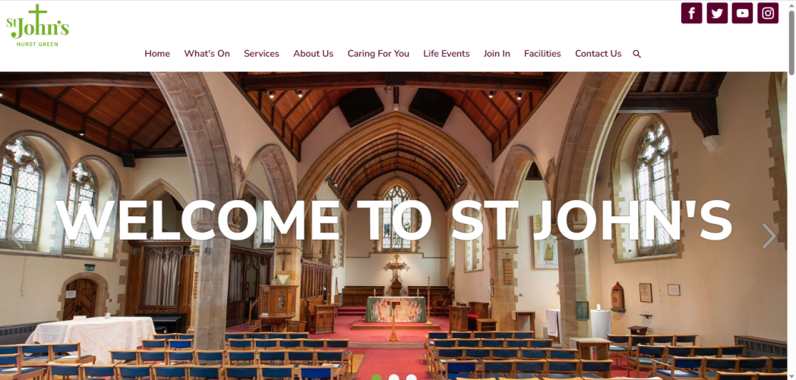
Church Life and Worship

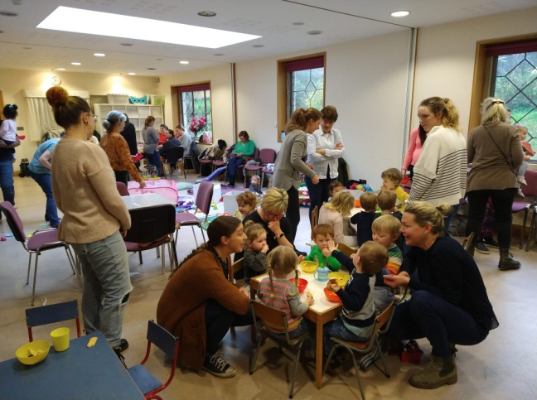
During this last year most of the activities and services of pre-COVID days are now happening once more. YoYos baby and toddler group and the Fortnightly Coffee morning go from strength to strength and are regularly welcoming new people. We are now taking services again in David Gresham House and Windmill Manor as well as taking home communion to a few people who can no longer easily make it to St John’s.
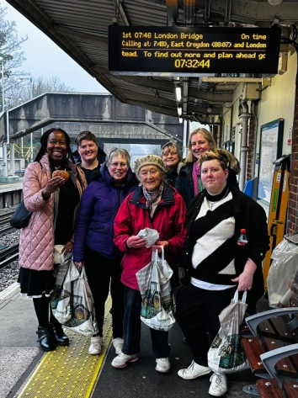
We do our best to be actively involved in Churches Together events and services and it was good this Lent to hand out hot-cross buns with local churches at Hurst Green station to commuters. We also managed to host four study groups during Lent and we are hopeful that a couple of these will continue as home groups. One of the groups called ‘Deepening Faith’ was led by Lotwina, our curate, and has helped some adults to prepare for Confirmation.

As well as confirmations and many baptisms, discipleship has also been happening amongst a group of primary aged children who were welcomed to receive Holy Communion at our Candlemas service at the start of February following a few weeks of careful preparation which they loved. This was the first such service for 3 years and many of the children were siblings of the last cohort in 2020. It is such a privilege to spend time leading children into deeper faith in this way and they all took it very reverently - it was clearly an important step for them all.

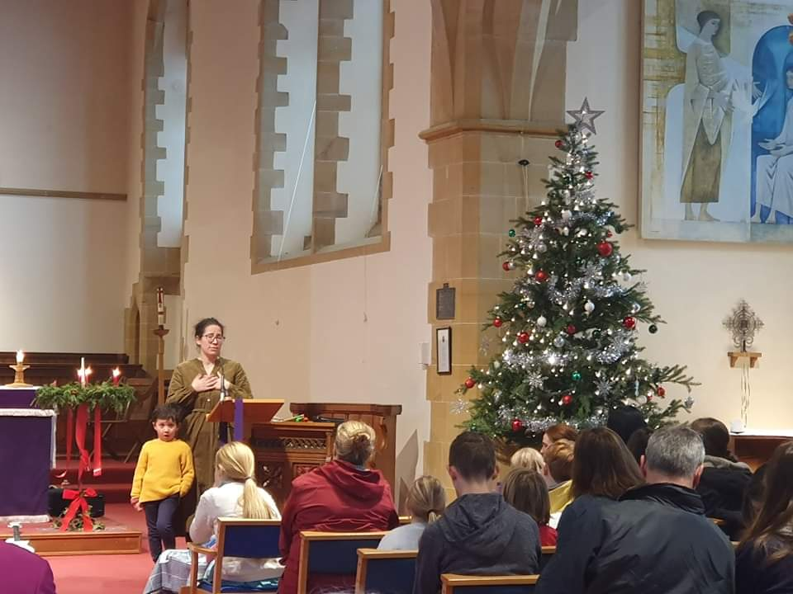
In September, we finally re-launched Café Church on the 3rd Sunday of the month. A new Community Brunch was also started after the 9.45am service and before Café Church so the two congregations can mingle and get to know each other. Since January, Lotwina has been developing Café Church in a new way inviting lay people to preach during this service which has been a real inspiration and blessing.

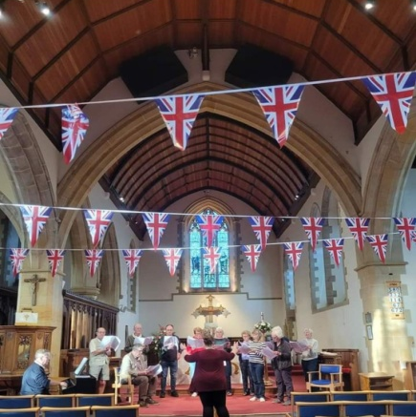
One way we are trying to be a church without walls is amongst us too. On Mothering Sunday the choir shared the worship with the Café Church band for a joint service at 10am and on Passion Sunday, the singers from across the churches and beyond came together accompanied by Hilary and led by Michael Harman for a service created by Michael for Passion Sunday. There was great attendance for what turned out to be a very moving service of beautiful music and readings.

Singers from across the Oxted Team also came together in May 2022 for Platinum Praise as we marked the Queen’s 70th year of reign after a special all-age service which had included puppets. Then, just a few months later, we grieved with our community at the death of Her Majesty.

Children and young people remain very important to our ministry and mission (Sunday School and Sunday Munch continue) and a youth group began in the summer ably led by a new youth worker called Mira alongside Abi Chapman who is trained in youth work too. Upper age juniors+ from across the Oxted Team enjoy games, hot chocolate, chat and a time of discussion and prayer every fortnight from 6-7.30pm in St John’s Room.

Using art as a bridge to the community has also featured. During the Easter season 2022 schools, care homes and other local groups created thought provoking ‘Stations of the Resurrection’ which were gradually revealed in church after Easter. This followed on from a similar event with Stations of the Cross a few years ago during Lent. It was a great way to challenge local people and groups to connect with the hopeful stories of the resurrection following the pandemic which had felt at times so hopeless. More recently a community mural was created at various community events co-ordinated by Abi Chapman which culminated in our Easter Day message this year which recognised how our personal stories (‘my story’) connects together as ‘our story’. Just like the first disciples each encountered the risen Christ individually, their sharing of stories formed the Jesus' story we join in with today.
Finally, we must remember the importance of hospitality and fellowship in all things. Our stalwart cake makers, soup makers and others keep the cogs of hospitality and welcome turning and social gatherings in local pubs have also recommenced. Sharing food and drink together was at the heart of Jesus’ ministry and the early church and we are grateful to all those who turn their hand to baking, cooking and serving, as well as all the organising of many different activities as outlined above, to ensure a warm welcome and connection with one another is known by all.

Vision and Mission
Since last year, our vision to be ‘a church without walls’ has really started to become a reality.

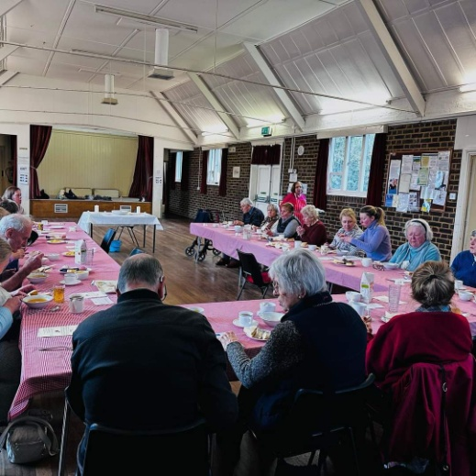
Firstly, the Community Hub runs every Thursday from 1-3pm in St Agatha’s Hall. Launched in November 2022 in collaboration with a local social enterprise, The Accessibility Project, it was a response to the call to provide warm hubs during a time of rising energy bills. Each week we provide a safe, free-to-access, all-inclusive space for people to come together, enjoy light refreshments, socialise and access pastoral support if required. We also provide one-off workshops and activities, often including a free lunch and celebrating festivals in the Christian calendar which attract a greater number of people. For example at the Christmas Community Hub over 100 adults and children attended and each received gift bags (given out by Father Christmas) which had been created by the Accessibility Project with many local volunteers. Although set up as a winter project, we will continue during 2023 because the hub is so popular. As we do so we hope to strengthen the bridge which St Agatha’s provides between the community and the church. One way we hope to do this is to have an Eco-focus, say once a month, hosting a refill station or repair café.

Secondly, Lotwina led a local team to start the Community Fridge in July 2022 which tackles food waste and inequality through the provision of excess surplus food products donated from local supermarkets, which are then provided to the local community, reducing the amount of product that ends up in landfill, and putting food on people’s plates. Each Wednesday, anyone and everyone is welcome to walk through our doors, collect a free bag of food, sit and enjoy free light refreshments, as well as accessing pastoral support as and when required. Like the Community Hub, the Fridge is a bridge that connects our church to our community.

To support our community members who may come from low-economic backgrounds, food vouchers, fuel vouchers and free Hygiene products through the Hygiene Bank are available too.

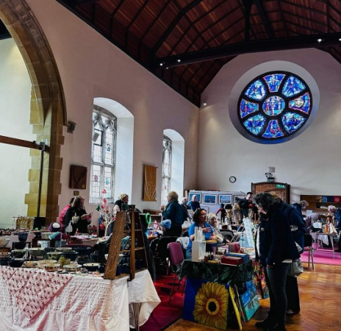
Thirdly, a new event now features in our calendar - the ‘Autumn Fair’ is a great demonstration of being a church without walls; chairs were moved and replaced by craft stalls and lots of local people came along. And we made some money too!

Following achievement of a bronze award, Eco-Church plans continue to develop. St John’s now has a strong and active Eco Group. The group have organised or attended various events:

- A talk on Carbon Capture and Storage, in January, by Chris Johns attended by 30+ people, many from the community
- Training - Becoming a Net Zero Carbon Church, Church Solar Panels and Church Heating
- A webinar about biodiversity given by the Surrey Wildlife Trust
- A planned visit to the Therapeutic gardens at St Mary’s, Lewisham in April, to see what they’ve been doing and inspire ideas for our own land use

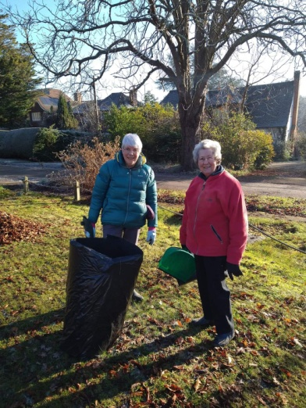
Possible future activities include starting a refill station and repair café, initially at the Community Hub (see above); community planting activities with Creative Community; developing a ‘sustainable and biodiverse’ grounds management plan; and an Eco theme at the Hurst Green Fair. All of these Eco actions seek to look outwards, connect with the community and inspire!

In addition, a significant focus is to review the St John’s heating system and consider ways to make it more sustainable and if possible, neutral, in terms of carbon emissions. We have made a great connection with the Greener Futures team at Surrey County Council who in March undertook an initial review of the building which will be followed by a more formal audit and recommendations. There will hopefully be funding available for improvements, all linked into Crossing the Threshold (see next).

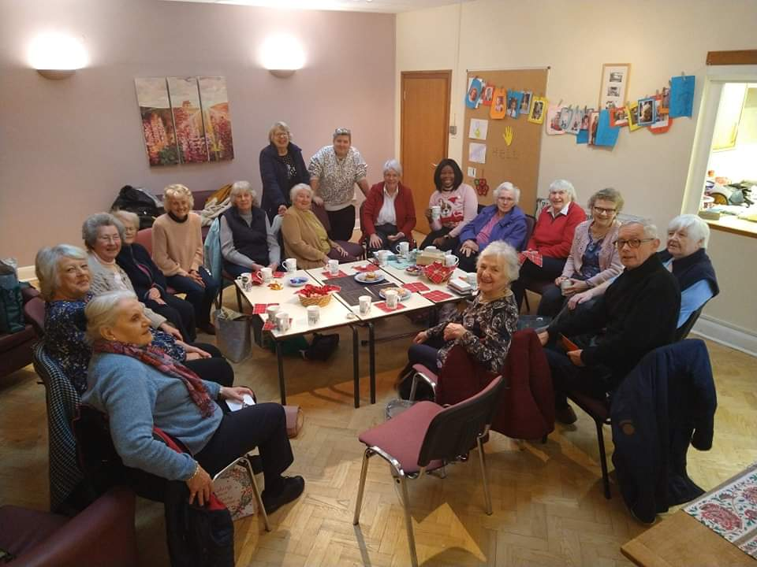
Finally, the Crossing the Threshold project, which has been bubbling away for a couple of years is also starting to become a reality. As well as considerable de-cluttering and re-organising of vestries and the tower, we are now preparing the ground to hire out the York Rooms on a more regular and permanent basis for a ‘flexi-school’. The organisation called ‘Keeta’, which means the ‘blessing or gift of offspring’, aims to help those children who are struggling to learn in mainstream school. This educational help and support will meet a pressing local need, but it will also mean there is significant re-imagining of the wider church space which is now necessary to accommodate groups such as YoYos, Yoga, the Coffee Morning, and in time other community meetings and groups.

The PCC have prayed about this decision and feel strongly that the Holy Spirit is guiding St John’s into this new phase of making the gift of buildings in our care much more available and useful to the community while not losing the prayer and worship at its heart. Ché Ramsden is our Bid Project Manager tasked with unlocking funding to begin to make our vision ‘to be a church without walls at the heart of our community’ a reality and a small team of focussed and dedicated individuals will be driving this forward over the coming months.

In all that St John’s is doing and planning, we are simply trying to follow in the footsteps of Jesus who encountered all kinds of different people, all over the place, sharing as he did so God’s healing and wholeness, faith, hope and love. There are too many people to mention by name who make all of these things possible but without their faith and commitment to God and God’s faithfulness to us such variety would not happen.
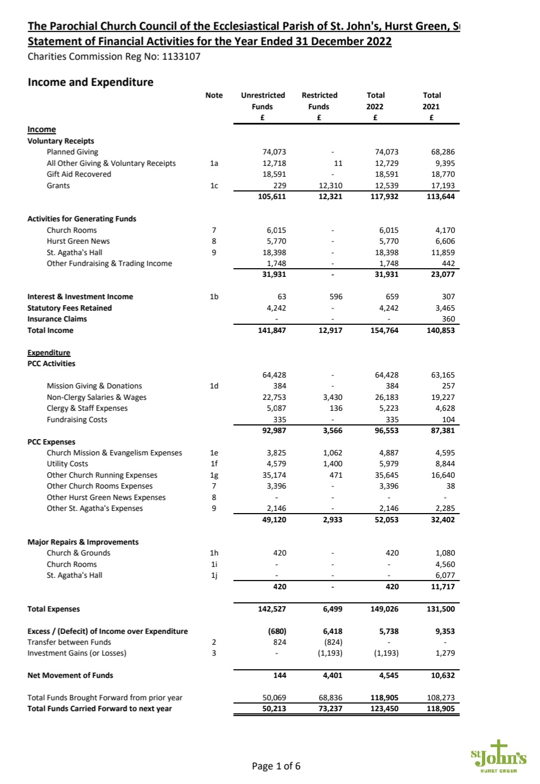
Accounts
